Time Series Forecasting: Comparative Analysis of Forecasting Models for Tata Elxsi Stock Price Prediction
Group 10
Debkanta Chakraborty (DM263023)
Susnata Majumder (DM262079)
Avilash Hazra (DM263014)
Dwaipayan Moitra (DM264029)
Ameya Ghagare (DM262009)
Date: December 2024

Executive Summary
This report presents a comprehensive analysis of time series forecasting models applied to Tata Elxsi Limited stock prices. We evaluated eight different forecasting approaches, ranging from simple moving averages to sophisticated ARIMA models. Our analysis reveals that simpler moving-average-based methods, particularly EWMA and WMA, significantly outperformed more complex models. Additionally, we conducted a separate volatility analysis using GARCH models to understand risk dynamics. The findings have practical implications for financial analysts and portfolio managers seeking reliable short-term price forecasting methods.

1. Introduction
1.1 Background and Motivation
Financial time series forecasting represents one of the most challenging yet essential tasks in corporate analytics, portfolio management, and strategic decision-making. The ability to accurately forecast stock prices can provide competitive advantages in investment decisions, risk management, and capital allocation strategies.
Stock prices are characterized by:
- Inherent noise
- Structural breaks due to market events
- Non-stationarity where statistical properties change over time
- Volatility clustering where periods of high volatility tend to follow each other
- Irregular trends that do not follow predictable patterns
These properties necessitate careful consideration when selecting appropriate forecasting methodologies.
1.2 Research Objectives
The primary objectives of this research project are organized around four key areas:
- Examine and analyze a real-world financial time series dataset from the Indian equity market
- Identify and document important patterns, trends, and anomalies through exploratory analysis
- Apply multiple forecasting models covered in academic coursework to evaluate their practical applicability
- Assess model performance using standard error metrics to determine which approaches are most suitable for stock price forecasting
1.3 Scope and Limitations
This study focuses specifically on price-level forecasting for short to medium-term horizons. We acknowledge that stock price prediction is inherently uncertain, and past performance does not guarantee future results. Our analysis is limited to the specific characteristics of Tata Elxsi stock and may not generalize to all financial instruments. Additionally, we do not incorporate external variables such as macroeconomic indicators, company fundamentals, or market sentiment, which could potentially improve forecast accuracy.

2. Data Description
2.1 Asset Selection and Justification
For this analysis, we selected Tata Elxsi Limited, a prominent player in the Indian technology and design services sector. Tata Elxsi is listed on the National Stock Exchange (NSE) of India and represents a liquid, actively traded stock with sufficient historical data for robust time series analysis. The company's stock exhibits typical characteristics of mid-cap technology stocks, including growth trends, volatility periods, and market-driven fluctuations.
2.2 Data Specifications
Property | Specification
Asset | Tata Elxsi Limited
Market | Indian Equity Market (NSE)
Frequency | Daily trading data
Variable of Interest | Closing price
Data Source | Yahoo Finance
Time Period | Multiple years of historical data
Sample Size | Sufficient for training and testing

Table 1: Data specifications for Tata Elxsi analysis
2.3 Variable Selection
We chose daily closing prices as our primary variable for several important reasons:
- Consensus value: Closing prices represent the final consensus value at which buyers and sellers agreed at the end of each trading session
- Industry standard: Commonly used by both academic researchers and industry practitioners for forecasting applications
- Simplicity: Closing prices eliminate intraday noise and provide a consistent single data point per trading day
- Information retention: Simplifies the modeling process while retaining essential information about price movements

3. Exploratory Data Analysis
3.1 Overall Price Dynamics
Our initial examination of the Tata Elxsi price series revealed several noteworthy characteristics:
- Substantial upward and downward movements interspersed with periods of relative consolidation
- Mean level of the series is not constant but changes over time
- Classic indicator of non-stationarity, which has significant implications for model selection
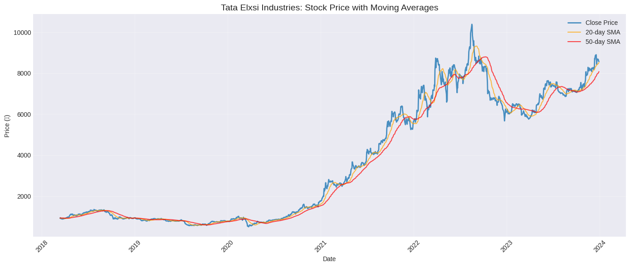
Non-stationarity means that the statistical properties of the series, such as mean and variance, evolve over time rather than remaining constant. Many classical time series models, particularly ARIMA models, assume stationarity for optimal performance.
3.2 Volatility Patterns
We observed distinct periods of high and low volatility:
- Some time periods show large daily price swings, indicating heightened uncertainty
- Other periods display relatively calm trading with smaller day-to-day fluctuations
- This volatility clustering (ARCH effect) is a well-documented phenomenon in financial markets
3.3 Short-Term Price Behavior
Despite the presence of long-term trends, short-term price changes exhibit considerable noise and what appears to be local momentum. There are periods where prices show directional persistence, but this momentum is not consistent and is often overwhelmed by random fluctuations.
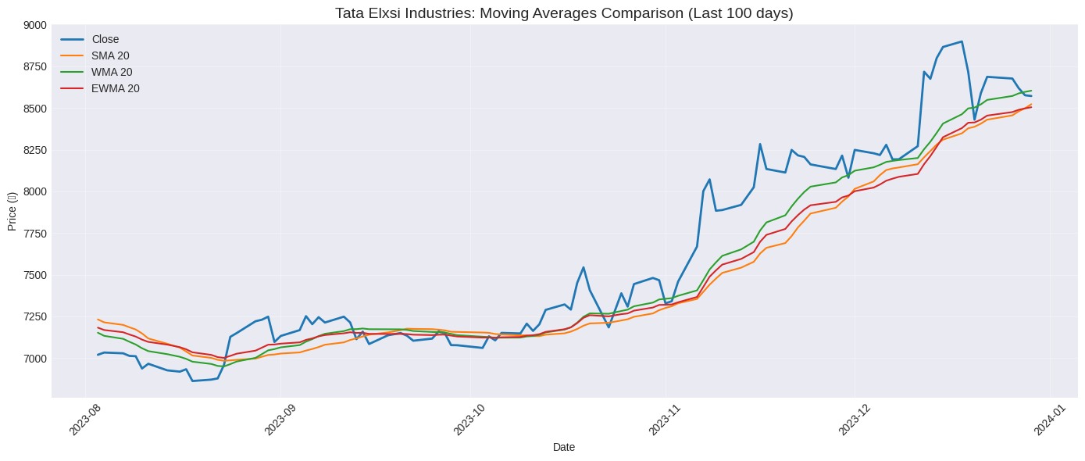
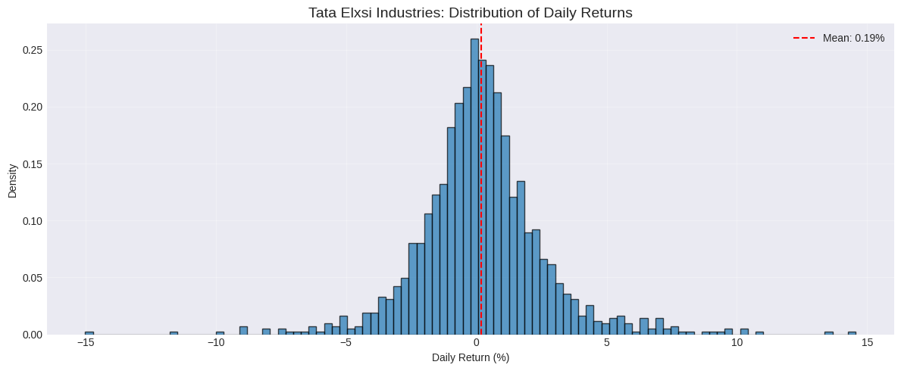
Key insight: Forecasting methods that emphasize recent observations may capture these local patterns more effectively than models that weight all historical data equally.

4. Methodology
4.1 Research Design
Our research follows a standard time series forecasting methodology designed to ensure objective and comparable evaluation of different models:
- Split data into distinct training and testing periods
- Fit each model using only training data
- Generate forecasts for the test period
- Compare actual outcomes with forecasted values using quantitative metrics
4.2 Train-Test Split Strategy
To objectively evaluate forecasting performance and avoid overfitting:
- Training set: Approximately 80% of observations for estimating model parameters
- Test set: Remaining 20% for evaluating out-of-sample forecasting performance
This temporal split maintains the time series structure, mirroring real-world scenarios where we use historical data to predict future outcomes.
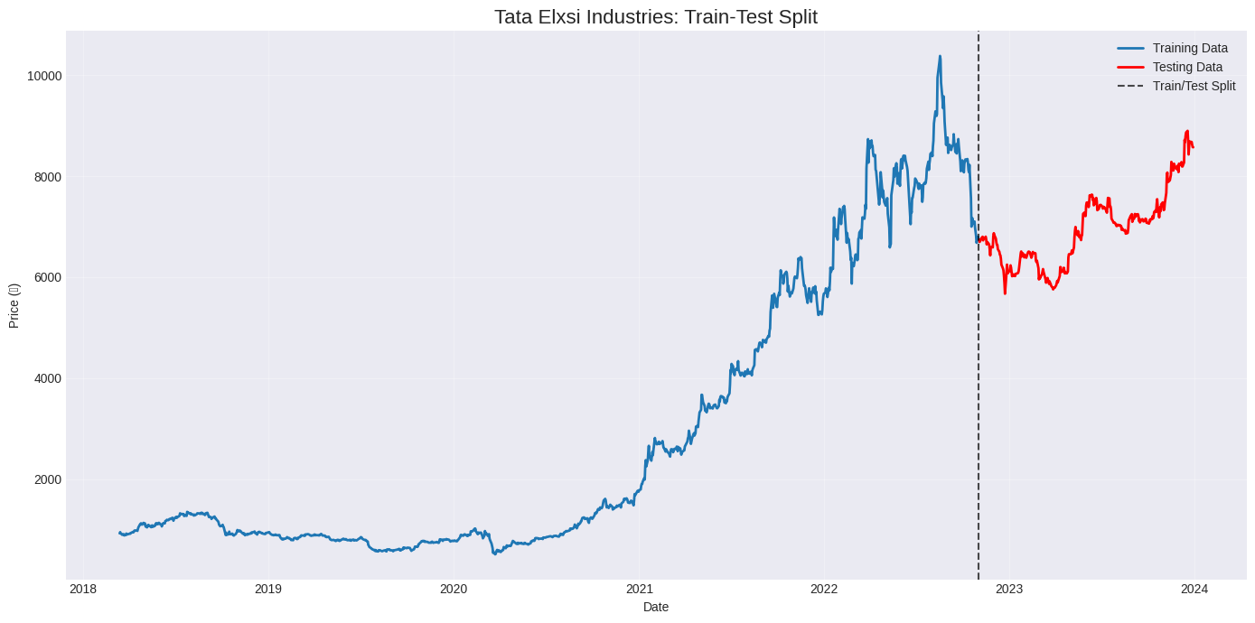
4.3 Forecasting Models Implemented
We implemented and evaluated eight distinct forecasting approaches:
Simple Moving Average (SMA): Calculates forecasts by averaging a fixed number of recent observations
Weighted Moving Average (WMA): Assigns different weights, typically giving more weight to recent observations
Exponentially Weighted Moving Average (EWMA): Uses all past observations with exponentially decreasing weights
Simple Exponential Smoothing (SES): Formal statistical method similar to EWMA
Holt's Linear Trend Model: Extends SES by explicitly incorporating a trend component
Holt-Winters Additive Model: Adds seasonal component to level and trend (absolute)
Holt-Winters Multiplicative Model: Seasonal effects scale with the series level (proportional)
ARIMA/SARIMA Models: AutoRegressive Integrated Moving Average models including seasonal components
4.4 Parameter Selection
For each model:
- Moving average methods: Tested various window lengths to identify optimal values
- Exponential smoothing methods: Used optimization algorithms to select smoothing parameters minimizing in-sample errors
- ARIMA models: Employed information criteria (AIC and BIC) with residual diagnostics for model order selection

5. Model Performance Evaluation
5.1 Evaluation Metrics
We employed two widely accepted error metrics that capture different aspects of forecast quality:
Root Mean Squared Error (RMSE)
$$\text{RMSE}=\sqrt{\frac{1}{n}\sum_{i=1}^{n}{ } (y_{i}-{\overset{ˆ}{y}}_{i})^{2}}$$
This metric calculates the square root of the average squared differences between forecasted and actual values. RMSE gives more weight to larger errors and is sensitive to occasional large forecasting mistakes. Lower RMSE values indicate better forecast accuracy, expressed in the same units as the original data.
Mean Absolute Percentage Error (MAPE)
$$\text{MAPE}=\frac{100}{n}\sum_{i=1}^{n}{ }\left|\frac{y_{i}-{\overset{ˆ}{y}}_{i}}{y_{i}}\right|$$
This metric expresses forecast errors as percentages of actual values. MAPE provides a scale-independent measure of accuracy, useful for comparing forecast performance across different time periods or assets. Lower MAPE values indicate better relative forecasting accuracy.
5.2 Performance Comparison Results
Our comprehensive evaluation yielded clear and consistent results:
- Moving-average-based models (SMA, WMA, EWMA) substantially outperformed more complex forecasting approaches
- Significant performance gap: Complex models often produced forecasts that either overshot or lagged behind actual price movements
- Better error metrics: Simpler methods achieved noticeably lower values for both RMSE and MAPE
5.3 Visual Comparison of Forecasts
Visual inspection of forecast plots provided additional insights:
- Moving average models produced forecast trajectories that tracked actual prices more closely
- Models like Holt-Winters and certain ARIMA specifications generated forecasts that often diverged significantly from realized prices
- Visual evidence supported numerical metrics: simpler models without strong structural assumptions performed better

6. Analysis of Best Performing Models
6.1 Top Performers: EWMA and WMA
Based on comprehensive evaluation using both RMSE and MAPE metrics, two models emerged as clear winners:
- Exponentially Weighted Moving Average (EWMA)
- Weighted Moving Average (WMA)
These models consistently delivered the lowest forecast errors across the entire test period.
6.2 Factors Contributing to Superior Performance
Emphasis on Recent Information
Both EWMA and WMA assign greater weight to recent price observations. This weighting scheme proves particularly valuable for stock price forecasting because recent prices contain the most relevant information about near-term price movements. Market conditions change rapidly, new information arrives, and sentiment shifts accordingly.
Minimal Structural Assumptions
Unlike Holt-Winters or ARIMA models, which impose specific assumptions about trends and seasonality, moving average models make very few assumptions. They simply smooth recent price movements to filter out noise while preserving genuine price signals. In the context of stock prices exhibiting complex dynamics, this flexibility proves advantageous.
Rapid Adaptation to Local Changes
Financial markets shift quickly in response to news, earnings announcements, and economic data releases. EWMA and WMA can respond rapidly to genuine directional changes through their emphasis on recent data and simple update mechanisms.
Avoidance of Overfitting
Complex models face the risk of overfitting—learning noise in training data rather than genuine patterns. Moving average models, with their simpler structure and fewer parameters, face less risk of overfitting while capturing broad patterns without distraction from random fluctuations.
Computational Efficiency
These models are computationally efficient and numerically stable. They do not require iterative optimization algorithms that might converge to local optima or fail to converge. This robustness makes them reliable for operational forecasting systems.

7. Analysis of Underperforming Models
7.1 ARIMA and SARIMA Models: The Stationarity Problem
ARIMA models are based on the fundamental assumption of stationarity. A stationary series has constant mean, constant variance, and stable autocovariances. While differencing can sometimes induce stationarity, stock prices present persistent challenges.
Stock prices exhibit evolving non-stationarity: the nature of the non-stationarity itself changes over time. During some periods, prices trend upward; during others, they trend downward or move sideways. Structural breaks occur when market regimes change.
Consequences for ARIMA:
- Fit training data by identifying patterns that existed during training
- Fail to adapt when those patterns change in the test period
- Continue reflecting old patterns that are no longer relevant
- Cannot capture nonlinear behavior and asymmetric responses to news

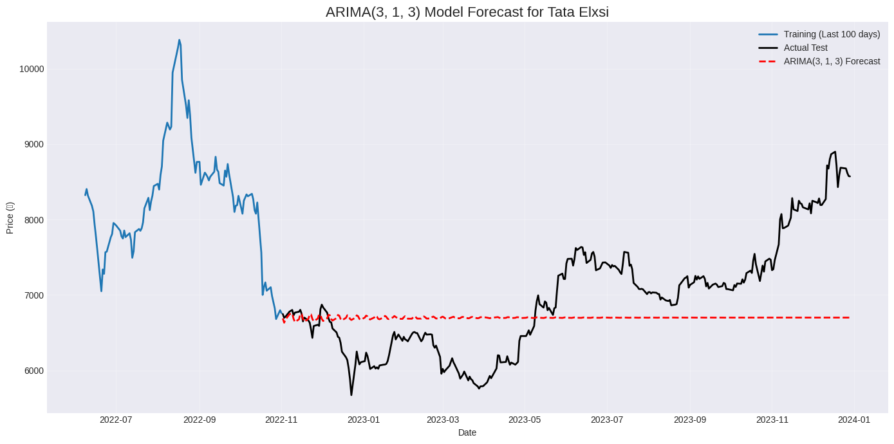
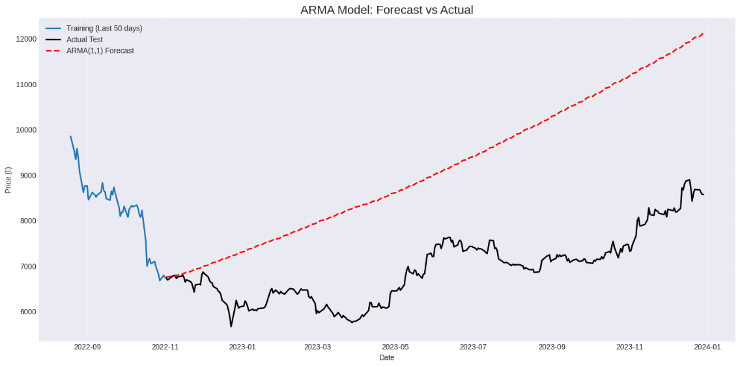
7.2 Holt's Linear and Holt-Winters Models: Inappropriate Structure
Holt's Linear Trend Model assumes the series has a consistent trend component that changes smoothly. This works well for gradually growing sales or production but is poorly suited to stock prices, which do not have stable, smooth trends.
Holt-Winters Models add seasonal pattern assumptions. While some financial series might exhibit weak seasonality, stock prices generally do not show the kind of stable, deterministic seasonality these models are designed to capture.
Result: Attempts to extract and project seasonal patterns that do not actually exist introduce systematic biases into forecasts, resulting in poor performance.
7.3 Simple Exponential Smoothing: Missing the Trend Component
Simple Exponential Smoothing is designed for series that fluctuate around a stable level without strong trends. When applied to stock prices with directional movement:
- Systematically underforecasts during uptrends
- Systematically overforecasts during downtrends
- Produces forecasts that lag behind actual price movements
- Results in consistently poor performance on trending data

8. Volatility Analysis Using GARCH Models
8.1 The Distinction Between Price and Volatility
An important conceptual distinction in financial time series analysis:
- Price forecasting: Attempts to predict where prices will be in the future (actual price level)
- Volatility forecasting: Attempts to predict how much prices will fluctuate (magnitude of movements)
Both are important for different purposes but require different tools and evaluation criteria.
8.2 ARCH Effects and Volatility Clustering
We tested for ARCH (AutoRegressive Conditional Heteroskedasticity) effects. ARCH effects manifest as volatility clustering—the tendency for large price changes to be followed by large changes (of either sign) and small changes by small changes.
We applied the ARCH LM test to the log return series:
$$\text{Log Return}=ln⁡\left(\frac{P_{t}}{P_{t-1}}\right)$$
Test results clearly confirmed the presence of ARCH effects, indicating that volatility is not constant over time but rather clusters in periods of high and low volatility. This finding justified the application of GARCH models.
8.3 GARCH(1,1) Model Specification and Results
We estimated a GARCH(1,1) model on the log return series:
$$σ_{t}^{2}=ω+αu_{t-1}^{2}+βσ_{t-1}^{2}$$
The GARCH(1,1) specification includes one lagged squared return term and one lagged conditional variance term. The estimated GARCH model successfully captured volatility clustering patterns:
- High volatility periods: Model's conditional variance increased
- Calm periods: Model's variance forecasts decreased appropriately
This information is crucial for risk management, option pricing, and portfolio construction.
8.4 Why GARCH Was Not Included in Price Forecasting Comparison
Although GARCH models are powerful, we deliberately excluded them from price forecasting comparisons for several reasons:
Different objectives: GARCH models forecast conditional variance (risk), not price levels
Different variables: GARCH operates on return series; price models operate on price levels
Different evaluation criteria: Price forecasts use RMSE/MAPE; variance forecasts need different metrics
Methodological consistency: Good research compares like with like
Price forecasting and volatility modeling represent distinct analytical tasks requiring different approaches.

9. Key Findings and Insights
9.1 Summary of Major Findings
Our comprehensive analysis yielded several important findings:
Superior Performance of Simple Models
Exponentially Weighted Moving Average (EWMA) and Weighted Moving Average (WMA) methods significantly outperformed more complex alternatives. This result challenges the common assumption that more sophisticated models necessarily deliver better forecasts.
Importance of Recent Data
Models emphasizing recent observations performed better than those treating all historical data equally. This finding aligns with the efficient market hypothesis suggesting new information is quickly incorporated into prices.
Mismatch of Structural Models
Models imposing specific structural assumptions performed poorly because these assumptions did not match actual stock price behavior. This highlights the danger of applying theoretically elegant models without considering whether their assumptions align with data characteristics.
Separate Treatment of Volatility
GARCH models excel at capturing time-varying volatility. However, price forecasting and volatility modeling represent distinct problems requiring different tools.
9.2 Practical Implications
Model Selection Guidance
When facing short-term stock price forecasting tasks, analysts should give serious consideration to simple moving average methods—particularly EWMA and WMA—before defaulting to more complex approaches.
Realistic Expectations
Even the best-performing models exhibited meaningful forecast errors. Stock prices remain inherently difficult to predict with high accuracy. Analysts should maintain realistic expectations and use forecasts as one input among many rather than as precise predictions.
Complementary Analysis
Price forecasting should be complemented with volatility analysis using appropriate tools like GARCH models. Understanding both expected price movements and uncertainty provides a more complete picture for decision-making.
9.3 Theoretical Implications
Parsimony Principle
The strong performance of simple models provides empirical support for parsimony—the idea that simpler explanations should be preferred when they perform as well as complex alternatives. In forecasting characterized by noise and structural instability, simplicity often provides more robust results.
Limits of Statistical Modeling
Poor performance of theoretically sophisticated models suggests limits to statistical modeling of stock prices. Stock prices reflect aggregation of millions of decisions responding to vast information—a complex process not well-captured by traditional statistical models.
Adaptive vs. Structural Approaches
Results favor adaptive approaches emphasizing recent data and minimal assumptions over approaches attempting to identify long-term structural patterns. This distinction is particularly important for financial forecasting where structural change is frequent.

10. Limitations and Future Research Directions
10.1 Study Limitations
Single asset focus: Analysis focused exclusively on Tata Elxsi, limiting generalizability
Limited forecasting horizon: Focus on short-term forecasting; longer horizons may show different relative performance
Univariate analysis: Models used only historical price series; incorporating volume, market indices, or macroeconomic variables might improve accuracy
Sample period: Analysis covers specific time period; different market regimes might favor different models
Fixed parameters: Used parameters estimated once from training data; rolling estimation might improve performance
10.2 Directions for Future Research
- Multi-asset comparison: Apply methodology to diverse stocks across sectors to test generalizability
- Multivariate models: Incorporate additional predictive variables including fundamentals and macroeconomic data
- Ensemble approaches: Combine forecasts from multiple models to achieve better performance
- Machine learning methods: Apply neural networks, random forests, or gradient boosting for comparison
- Regime-switching models: Recognize different market regimes and adapt forecasting approach accordingly
- Real-time implementation: Develop and test real-time forecasting systems in live market conditions

11. Conclusion
This comprehensive study examined the challenge of forecasting stock prices using various time series methodologies applied to Tata Elxsi Limited stock data. Through rigorous analysis involving eight different forecasting approaches, clear patterns emerged regarding what works and what does not in financial price forecasting.
Key Conclusion: Simpler models based on moving averages outperform theoretically sophisticated alternatives for short-term stock price forecasting. Specifically, EWMA and WMA methods delivered consistently superior performance compared to exponential smoothing variants, Holt-Winters models, and ARIMA/SARIMA specifications.
Performance stems from:
- Emphasis on recent information, most relevant for stock prices
- Minimal structural assumptions, avoiding inappropriate trend or seasonal patterns
- Quick adaptation to changing market conditions
- Avoidance of overfitting risks plaguing complex models
Counterintuitive Finding: Models that performed poorly imposed structural assumptions about trends, seasonality, or stationarity that did not align with actual stock price behavior. When assumptions were violated, models diverged substantially from realized prices.
Separation of Concerns: Our volatility analysis using GARCH models reinforced an important distinction—price forecasting and volatility modeling represent different analytical tasks requiring different tools. GARCH excels at capturing time-varying volatility for risk management, while price-level forecasting requires adaptive, recent-data-emphasizing approaches.
Practical Guidance: When choosing forecasting methods, practitioners should carefully consider the match between model assumptions and data characteristics rather than simply selecting the most sophisticated available method. Forecasts should serve as one input among many in decision-making rather than precise price predictions.
Broader Perspective: This research contributes to forecasting literature by providing evidence for the parsimony principle—in noisy, complex environments, simple, flexible models often outperform complex models imposing rigid structures.
Final Insight: In financial forecasting, as in many domains, simple approaches that acknowledge uncertainty and adapt flexibly to new information often outperform complex models imposing rigid structure. This lesson extends beyond Tata Elxsi stock to broader discussions about model selection, forecasting methodology, and appropriate complexity levels for practical analytical tasks.

References
[1] Box, G. E., & Jenkins, G. M. (1970). Time series analysis: Forecasting and control. Holden-day.
[2] Bollerslev, T. (1986). Generalized autoregressive conditional heteroskedasticity. Journal of Econometrics, 31(3), 307-327.
[3] Makridakis, S., Spiliotis, E., & Assimakopoulos, V. (2018). Statistical and machine learning forecasting methods. International Journal of Forecasting, 34(4), 734-755.
[4] Hyndman, R. J., & Athanasopoulos, G. (2021). Forecasting: principles and practice (3rd ed.). https://otexts.com/fpp3/
[5] Nelson, D. B. (1991). Conditional heteroskedasticity in asset returns. Journal of Econometrics, 45(1-2), 227-251.
[6] Roberts, S. A. (1959). Control chart tests based on geometric moving averages. Technometrics, 1(3), 239-250.
[7] Engle, R. F. (1982). Autoregressive conditional heteroscedasticity with estimates of variance of United Kingdom inflation. Econometrica, 50(4), 987-1007.
[8] Hamilton, J. D. (1994). Time series analysis. Princeton University Press.

